Producer – the program/logic that puts data into kafka
Here our python logic that contains –
Connects with coinbase
Subscribe
Receive msg
Validate data
Add metadata
Choose kafka topic/key
Put
Handle failure

Kafka Cluster – Group of Brokers
Broker – Actual Server that stores and publish data
Topic- Logical Dividation
Partition - unit of ordering and parallelism. – (e.g. BTC-USD, ETH – USD, SOL – USD)
Replication = copies of partition across brokers for fault tolerance.
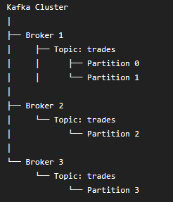

In our project we have 3 brokers, with 3 partitions with 3 replication
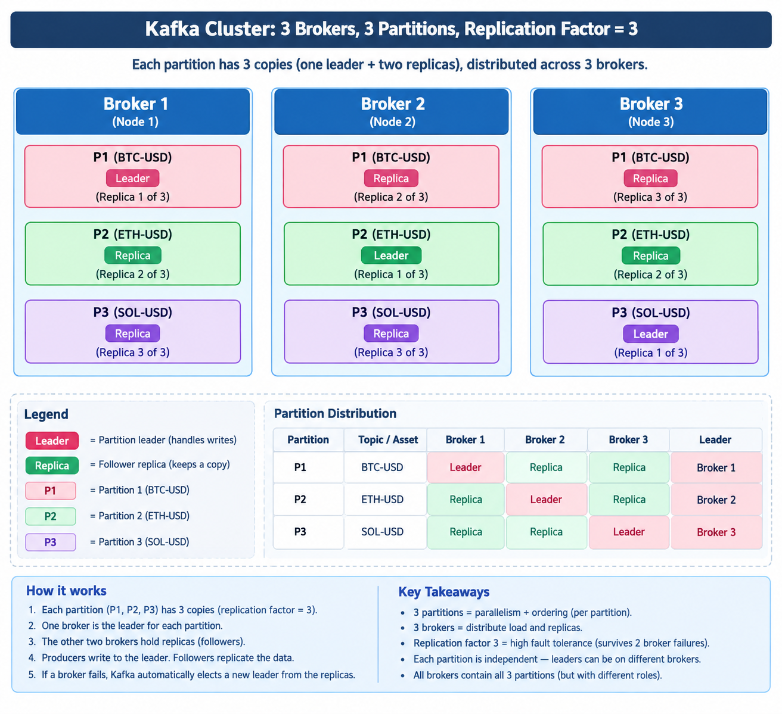
Bootstrap server in docker compose file - the entry-point address your producer uses to make its very first network connection to the Kafka cluster.

Verification Checklist
Once the whale icon in the bottom-left corner of Docker Desktop turns green ("Engine running"):
- Check the Virtual Disk: Open File Explorer and navigate to J:\Applications\Docker\images. You will now see an ext4.vhdx file created there.
- Check Settings in Docker Desktop:
  - Click the Settings (gear icon) at the top right.
  - Select Resources Advanced (or Virtual disk location).
  - Confirm that Virtual disk location displays J:\Applications\Docker\images.
You are now running 100% of Docker Desktop's application binaries, virtual disk images, containers, logs, and CLI caches on your J: drive!

